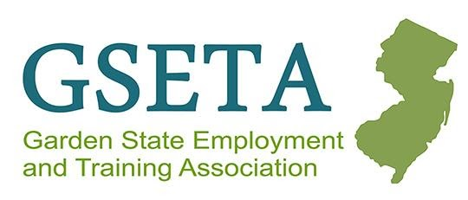
GSETA Youth Meeting Meetings
Wednesday December 6, 2023
10:00AM Zoom Meeting

Self- Attestation: Mark VanKampen NJDOL
- Review of TEGL 23-19 Change 2: Guidance validating Self-Attestation
- Expanded use of self-attestation in addition to documentation
- Goal is to reduce the number of obstacles for participants
  - Do not want to deny or delay services due barriers obtaining documentation
- Can accept written/electronic declaration and signature by participant
  - Examples: email, text, online survey response, screen shot, etc.
- Needs to be traceable to the participant
- Available templates for self-attestation NJWIN3-16 or WDPY 19-6
- Helps ensure equitable access to services for most at need populations.
- Use middle of the road approach
- If using self-attestation, documentation does not need to be collected at any point, however, supportive services should be utilized to assist participant in obtaining documents that are necessary for employment.
- Data entry:
  - Disability – USDOL wants to collect data on type of disability
  - Youth needing additional assistance – should be used as a last resort when no other barriers exist other than basic skills deficient.
  - Capture as many barriers that exist – this is used for the statistical adjustment model.
- CANNOT use self-attestation for:
  - Basic skills deficient
  - Public assistance
  - Vet status (if sent to training)
  - Selective service
    - However, the reason a customer is not registered can be self-attested to based on local policy (high school dropout, incarcerated)
    - Encourage youth to register (can register at 17 ½)
    - If customer is of registration age and refuses to register – services should be discontinued.
- Should still verify employment authorization/citizenship.

Open Discussion:

- Round Table conference: Kim Clayton, Kali Rorke, Matt Llauget
  - case managers sharing best practices for working with youth
  - Being more mindful of approach and making customer feel comfortable
  - Setting aside data/entry or paperwork momentarily to be in the moment with customer
  - Take away: do not forget the human element of what we are doing
- Youth Quality Analysis: Mark VanKampen
  - Concern: Service in quarter
  - DOL expects a program element every quarter
  - Will be sending each area their results to monitor
- Providers having access to AOSOS
  - General discussion pros/cons
  - Concerns: giving access to vendors can lend itself to mistakes and errors that effect performance
  - How do we know when new policies come out – discussion around being notified when new policies are out and technical guidance that is needed.
- Comprehensive Guidance & Counseling activity:
  - Should be used when discussing and making referrals to mental health, substance abuse, etc. not academic related.
- Testing assessments
  - Education assessments can be assessments outside of CASA’s or TABE, this includes discussion regarding education, college credits, and collection of transcripts or progress reports.
  - Must be documented.

Review of Youth Symposium Las Vegas (11/5-11/8): Samantha Pfieffer:

- Networking for Introverts:
  - Importance of understanding and recognizing different personality traits and using it as part of assessment
  - Introverted vs. uninterested
  - Building self-confidence, creating benchmarks and starting slow
  - Helping introverted youth learn how to communicate, practice communicating and working through scenarios
- Funding Lost Youth
  - Overview of program to engage disconnected youth in Clark County, Las Vegas.
- Braiding Funding & Programming
  - Way to reengage youth
  - Funding with a purpose and filling in funding gaps
  - Recruitment – including families utilizing resources available to you

Open Discussion:

- Work Experience:
  - Wages vs. stipends for work experience
  - Are stipends allowable
  - Guidance will be shared

Meeting adjourned 11:24pm

Next meeting: Wednesday, March 6, 2024

