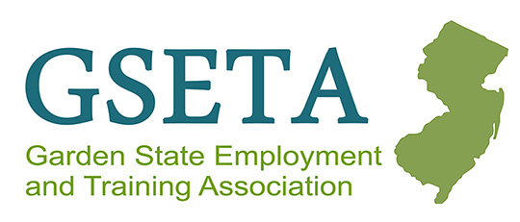

GSETA Fiscal Committee Meeting
Virtual via Microsoft TEAMs
December 12, 2023, at 9:00 AM

AGENDA

SAGE/IG16 Updates
- SAGE is receiving a face lift and will be moving to IGX platform SFY25
- Looking for a minimum of two staff per county to test system over the next few months
  - Sign up today: https://www.signupgenius.com/go/10C0B4CAEAA2CA3F4C61-46846536-volunteers
- Interactive training hopefully will occur in May 2024 with launch in June 2024
- User information will be transferred to new system
- New system will require data entry of same information from SAGE
- Will still be required to input SFY24 in SAGE whiling put SFY25 in the new IGX platform. This was decided to ensure no data transfer errors occurred.

NJDOL Internal Audit Updates
- Support for each cash drawdown
- Timely reporting, 15 of every month
- In person interviews after entrance conference one day during monitoring for SFY24
  - Employee interviews and ask to speak to a few people
  - But majority of work will be done virtually
  - Monitoring survey will be new, and web based
- Common issues with subrecipient support lines such as no payroll registers to support salary charges and no sign in sheets for youth food allowability indirect costs are being reviewed statewide.
  - Subrecipient support for salary lines, which should be payroll registers. Time sheets aren't proof of payment they are just proof of hours spent.
  - Need sign in sheets for who ate what meal
  - Need to have policy and ensure contracts on caps on food cost (i.e., sandwich is fine, not a three-course meal)
  - Providers should be giving meals and not snacks (large grocery orders with no proof of what was used by who)
  - Cost should be in alignment with GSA per diem rates for any meal
- Indirect cost meeting with USDOL in early January on how to look at this cost, what's allowable, what's acceptable, what kind of support you need to charge indirect cost
- Workforce Development Boards expected to perform Fiscal and Program monitoring and OIA will be following up with them.
- Federal DOL has selected Mercer and Gloucester counties for technical assistance
- Staff update, Irene has received a promotion to Director in Fiscal department

NJDOL Fiscal and Accounting – No updates

Q & A and Open Discussion – Happy Holidays, everyone!
- Ann Lord shared that we will be able to sign contracts soon and we should be hearing from WIOA POD as they are reviewing a few contract details.

Proposed Virtual Meeting Schedule
Tuesday, March 5, 2024, at 9:00 AM
Tuesday, May 21, 2024, at 9:00 AM

