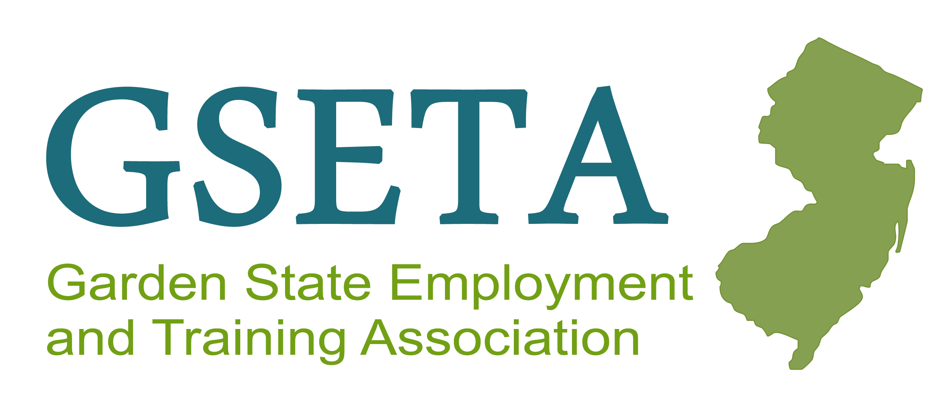

Nomination Packet for the

GSETA 2025 Awards

* Harry L. Wheeler Professional of the Year Award
* GSETA Public Service Award
* GSETA Corporate Partnership Award

May 1, 2025

Greeting GSETA Membership!

The 42nd Annual GSETA conference may seem far away but it will be here before we know it! I am therefore beginning the nomination process for the **2025** **Harry L. Wheeler Professional of the Year Award, the GSETA Public Service Award and the Corporate Partnership Award.** Enclosed you will find the following in relation to those awards:

* **A nomination form** for the three award categories
* **Criteria** for nominees
* **Instructions and rules** for the nomination process
* **A timeline** for the nomination process
* A list of **past award recipients** for the Professional of the Year and Public Service Awards.Unfortunately, we **do not** have a list of past recipients of the Corporate Partnership Award.

Please read the enclosed information and submission instructions carefully before submitting your nominations. **Only those nomination packets submitted in accordance with the instructions and meeting the criteria presented therein will be considered.**

Completed nomination forms and supporting information must be received by **August 15, 2025.** Nominations can be emailed to info.gsetatraining@gmail.com.

The GSETA Awards Committee, consisting of the past five (5) Harry L. Wheeler Award recipients, will review and evaluate the nomination packets. Upon evaluation, a selection will be made within the last two weeks of August. The announcement of the winners will be at the September 10th full board meeting.

This is a very meaningful GSETA activity, although you are extremely busy, please take a moment to vote. These awards are a reflection on each of us as individuals, the relationship with our partners, as well as the Association as a whole.

Thank you in advance for your time and participation in this process. Should you have any questions or need additional information in relation to the award process, please feel free to call or e-mail me at (856) 278-6607 or [info.gsetatraining@gmail.com](mailto:info.gsetatraining@gmail.com).

Yours Truly,

Samantha Pfeiffer

Executive Director



|  |
| --- |
| **NOMINATION FORM**  **2025 Harry L. Wheeler**  **Professional of the Year Award** |

***This award recognizes an individual who has demonstrated exceptional leadership, expertise, and dedication in their professional field. Nominees should exhibit a high standard of excellence, make a meaningful impact in their industry or community, and serve as a role model for peers and emerging professionals.***

**Part A. Nominee Information**

**Nominee: ______________________ Job Title: ____________**

**Organization: _____­­­­___________________**

**Address: ________________________________________**

**City: ___________________________ State: ________ Zip Code: _____**

**Phone Number: ________________ Fax Number: ______**

**Part B. Summary:** ***Provide a summary stating why you believe that the nominee should receive this award. Please attach to the nomination packet.***

**Part C. Endorsements: *Attach up to two (2) endorsements of the nominee. Only GSETA members in good standing may submit an endorsement. Endorsements must be typed and must act to support the nomination.***

**Part D. Nominator Information**

**Nominator’s Name: _______________________________________________**

**Organization: ___________**

**Phone Number: ____________________ Fax Number: _ ___**

**E-Mail: _ ____________________________________________________**

**________________________________ __________ ________________**

**Signature of Nominator Date**

|  |
| --- |
| **NOMINATION FORM**  **2025 Public Service Award** |



***This award honors an individual that has made significant contributions to the public good through service, advocacy, or volunteerism. Nominees should demonstrate a strong commitment to improving workforce development & their community, promoting equity or justice, and creating positive, lasting change through public service efforts.***

**Part A. Nominee Information**

**Nominee: ____________________________________ Job Title: ______________________________________**

**Organization: _______________________________________________________________________________**

**Address: ____________________________________________________________________________________**

**City: ________________________________________ State: ____________________ Zip Code: ___________**

**Phone Number: _______________________________ Fax Number: ________________________________**

**Part B. Summary: *Provide a summary stating why you believe that the nominee should receive this award. Be Please attach to the nomination packet.***

**Part C. Endorsements: *Attach up to two (2) endorsements of the nominee. Only GSETA members in good***

***standing may submit an endorsement. Endorsements must be typed and must act to support the nomination.***

**Part D. Nominator Information**

**Nominator’s Name: __________________________________________________________________________**

**Organization: _______________________________________________________________________________**

**Phone Number: __________________________________________ Fax Number: ____________________**

**E-Mail: _____________________________________________________________________________________**

**_________________________________________ ____________________________________________**

**Signature of Nominator Date**

|  |
| --- |
| **NOMINATION FORM**  **2025 Corporate Partnership Award**  **For Workforce and Economic Development Recognition** |

###### 



***This award is given to a company or organization that has provided outstanding support through sponsorship, partnership, or philanthropy. Nominees should have shown a clear commitment to community engagement, social responsibility, or mission alignment, and contributed meaningfully to advancing shared goals or initiatives.***

**Part A. Nominee Information**

**Organization: _________________________________________________________________**

**Address: _____________________________________________________________________**

**City: _____________________________________ State: __________ Zip Code: ________**

**Corporate Contact: ___________________________________________________________**

**Phone Number: ____________________________ Fax Number: __________________**

**Part B. Summary:** ***Provide a summary stating why you believe that the nominated corporation should receive this award. Please attach to the nomination packet.***

**Part C. Statement of Achievement: *Attach a separate sheet that details the nominee’s achievements. The statement must document what the corporation has provided to the New Jersey workforce and how that contribution has positively affected the economy consistent with the criteria established for the award. Specific results should be described. Any additional information on the history of the corporation’s economic development and/or corporate sponsorship of workforce development may be included to substantiate statements.***

**Part D. Endorsements: *Attach up to two (2) endorsements of the nominee. Only GSETA members in good standing may submit an endorsement. Endorsements must be typed and must act to support the nomination information provided in Part C.***

**Part E. Nominator Information**

**Nominator’s Name: ____________________________________________________________**

**Organization: _________________________________________________________________**

**Phone Number: __________________________________ Fax Number: _________________**

**E-Mail: ______________________________________________________________________**

**____________________________________ __________________________________**

**Signature of Nominator Date**

|  |
| --- |
| **2025 GSETA Awards: Eligibility Criteria for Nominees** |

**The Harry L. Wheeler Professional of the Year Award**

**A nominee for the Harry L Wheeler Professional of the Year Award must be a member in good standing of the Garden State Employment and Training Association who has demonstrated a**

**long-term commitment to the Association and to the workforce development community.**

**The individual’s efforts should be exemplary and innovative**. Successful candidates will be those who:

* Are active members of GSETA;
* Demonstrate outstanding involvement and commitment to workforce development;
* Display exemplary leadership skills at the State and local levels and amongst their peers;
* Have substantial workforce development responsibilities;
* Have planned, designed, and/or coordinated innovative services to customers and the

community;

* Are leaders in facilitating public-private partnerships that result in showcasing workforce development possibilities, opportunities, and results;
* Have had an identifiable and positive impact on workforce development in New Jersey;
* Have made a significant contribution to workforce development beyond the scope of their job responsibilities.

**The GSETA Public Service Award**

The **GSETA Public Service Award is designed to honor a non-GSETA member whose accomplishments in workforce development warrant special consideration. The individual must have a demonstrated record of genuine commitment that has resulted in a sustained positive impact on the workforce development field.** Nominees in this category must:

* Have a demonstrated record of positive impact on workforce development;
* Not be a current member of GSETA, nor eligible to be a member of GSETA;
* Have a key role in the workforce development field;
* Demonstrate widespread support of the workforce development community;
* Be instrumental in shaping workforce development policy on the Federal, State, and/or local level;
* Show a commitment to improving opportunities for customers of the publicly funded workforce development system.

**The GSETA Corporate Partnership Award**

**The GSETA Corporate Partnership Award** recognizes a corporation within the state of New Jersey that has provided a positive impact on the workforce through economic and workforce development. Nominations in this category must:

* Have contributed to the increase in the local and/or state workforce development;
* Provide a sustained commitment to working with local Workforce Investment Boards   
  to initiate leadership and direction in current and/or future workforce growth;
* Show participation in actively providing a role in the development of a strategy to   
  guide workforce customers into a growing workforce demand cluster;
* Have a record of the impact of corporate economic development on the local and/or state workforce;
* Be able to show documentation of the corporate influence on the local and/or state economy.

#### 2025 GSETA Awards: Nomination Instructions and Rules

1. Only Garden State Employment and Training Association (GSETA) members in good standing may submit nominations, endorsements, and/or vote for award recipients.
2. Each eligible GSETA member may submit only one nominee for the Harry L. Wheeler Professional Award, only one nominee for the GSETA Public Service Award, and only one nominee for the GSETA Corporate Partnership Award.
3. Past award winners are not eligible to receive an award again.
4. **Email will be accepted, however, all fully completed nomination packets (including endorsements) must be emailed by end of business August 15, 2025.**
5. The Awards Committee will consider only those nomination packets that contain ALL required information. ***All required information means that Parts A through E on the Nomination Form are FULLY completed***.
6. Nominations will be evaluated by the Awards Committee based on the content of the information provided by the nominators and the endorsees. It is important that nomination packets be thoroughly and professionally prepared.
7. To be declared an award recipient, an individual must receive at least 60% of the votes that are cast for the award for which he/she has been nominated.

#### 2025 GSETA Awards Timeline

### The following timeline will be used in relation to be determining GSETA’s 2025 Award recipients. Scheduled dates presented are subject to revision, as deemed reasonable and necessary Awards committee, to effectively complete its tasks. GSETA members will be informed in writing (via email) of any changes that are made to the timeline that would have a significant impact on the nomination and/or voting process.

**May 1, 2025 Nomination Packets Distributed to GSETA Members**

**August 15, 2025 Due Date for Nomination Packets to be submitted**

**Week of Aug 25, 2025 Awards Committee will review and evaluate submissions**

**September 10, 2025 Award Recipients Announced at GSETA Meeting**

**October 22, 2025 Awards Presented at GSETA Conference**

**Previous GSETA Award Recipients**

**Year Harry L. Wheeler Award Public Service Award**

**2025 *To Be Determined***  ***To Be Determined***

**2024 Leslie Williams* Paul McClellan**

**2023 Fran Kuhn* None**

**2022 None None**

**2021 None None**

**2020 None None**

**2019 Davidene Alpart* Literacy New Jersey**

**2018 Howard Weiss* Jeff Keller**

**2017 Donna Buchanan Linda Roma**

**2016 Allison Spinelli* Barry Semple**

**2015 Eileen Higgins None**

**2014 Tammy Molinelli* None**

**2013 Keith Davis Theodore Gooding**

**2012 Patricia Leahey Steve Reenstra**

**2011 Kelly West Rosemary Hufner**

**2010 Salvatore Mastroeni Maureen Craven**

**2009 Jack Patten Frank Guzzo**

**2008 Andrea Schaffel Deborah Rago**

**2007 MaryAnn Fulmore Tamara Thomas**

**2006 Carolyn Ellington Barbara DeGraaf**

**2005 Sharon M. Dutra JoAnn Hammill**

## 2004 Anthony Corsi Henry Plotkin

## 2003 None Jane Z. Brady

**2002 Michele Hutchison & Robert H. Ewing Hosea Johnson**

**2001 Virgin Velez Calvin O. Iszard**

**2000 Dante Rieti Woodrow Holmes**

**1999 Bill Wood Marilyn Shea**

**1998 None Robert H. Peabody**

**1997 Gary Altman Tom D’Elia**

**1996 Tamara Primas Mark Boyd**

**1995 Jean Koszulinski Carl Lillvik**

**1994 Charles Thomas Frank Lehr**